To initialise our website we had to decide what type of website we wished to create. So, me, Ciaran and Nathan would meet up and talk about the different types of websites that we could create. We tried the idea of creating a shopping website like Amazon or creating a games website but eventually we decided that a car website would be best, especially as I have a lot of knowledge in this area that could help us to build the website and its content.

We would create a mindmap in Miro for this website to see conceptualise our website’s index and a general frame. This was how we would plan the websites different pages and navigational features. We would also use screenshots from other car websites to understand how ours should look and be designed. This meant that we would have a professional looking website with good user navigation and design features. We gathered these screenshots.

<https://www.crawfordclarkecars.co.uk/>

<https://www.paulblaneymotors.com/>

https://www.seremotors.com/

Now that we knew what our website should look like and what it would be; a car website, me and Ciaran would meet up and create an index for the website. Ciaran was able to create wireframes of what the pages might look like.

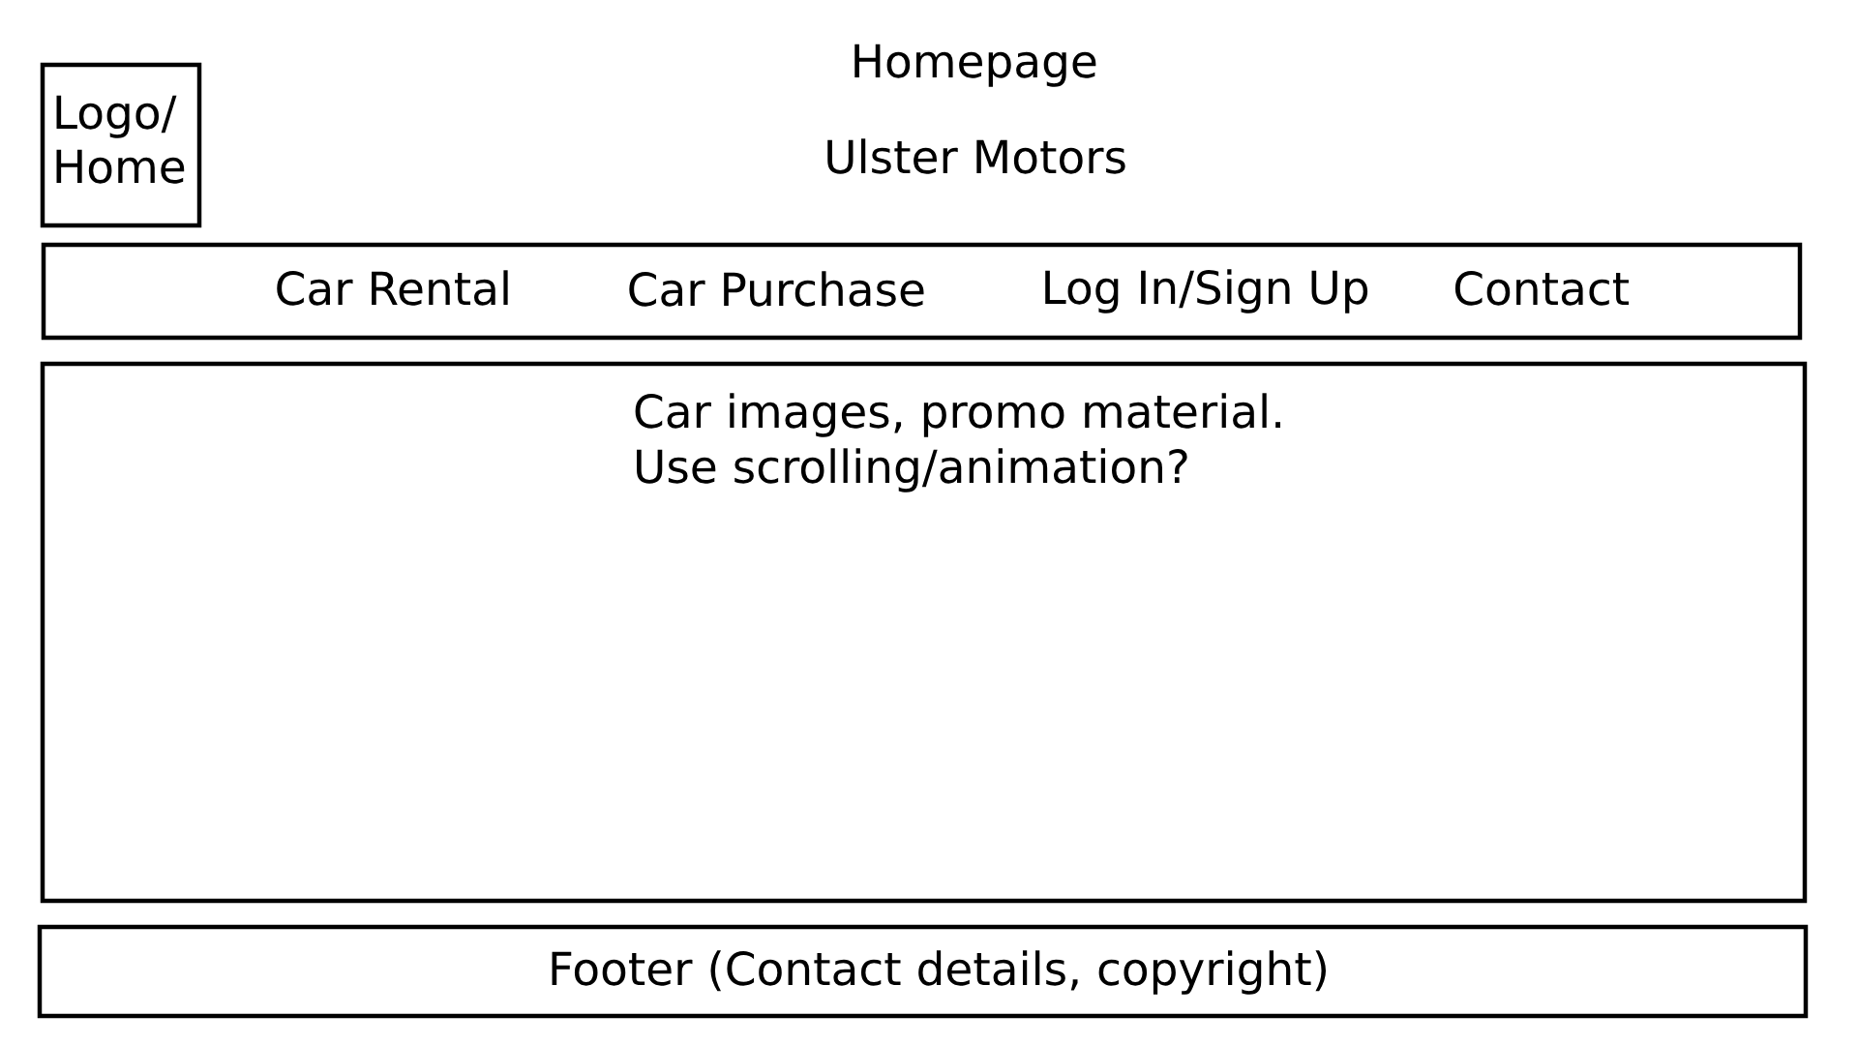

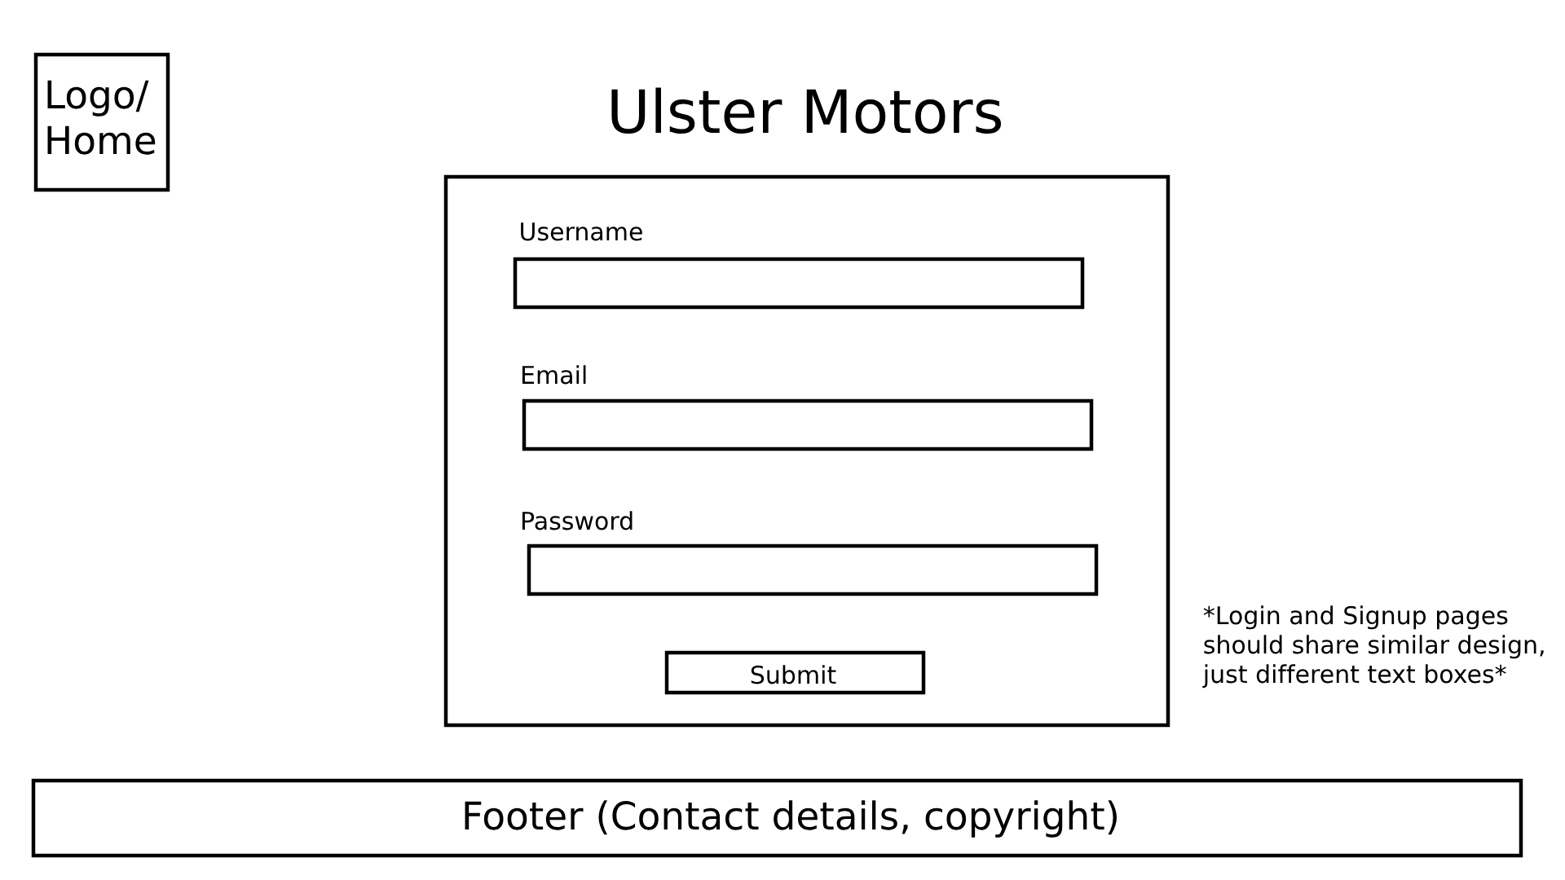

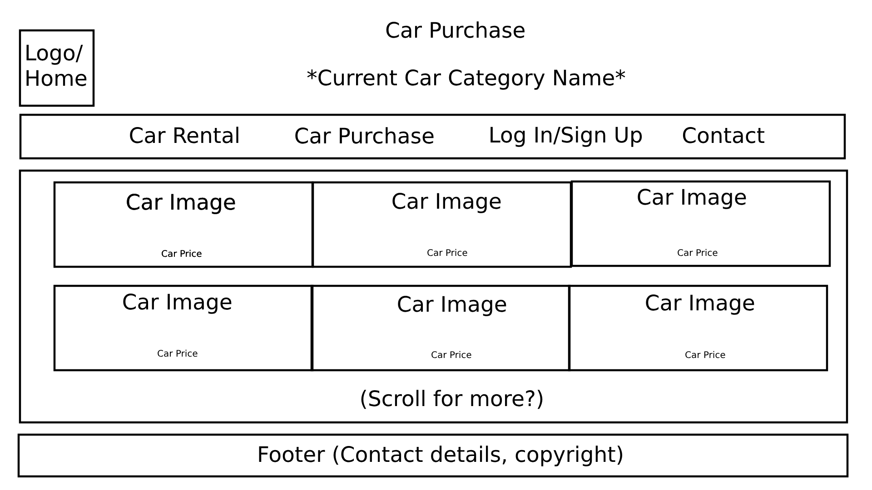

This was fine to start with but not what I wanted as a final product so after our meeting I would go home and focus and recreating the index. At the same time, Nathan had also created an index while he wasn’t present for our first meeting. For my index, it would contain a sub dropdowns for different car types under the main dropdowns of Car Purchase and Car Rental with ideas adding photos to the main menu of a car dealership as it would look more professional and similar to the websites that we had researched and agreed to make our websites look like. I also created a contact button that would alert the user with our business email address.

For the index I would also add a CSS file that would make the header black, the font white and the body font black as the body was blank. Then I would add a footer on the website that had our trademark on the website that would move down to the bottom of the website once we had added photos. This was difficult as at the start it would clip through the photos and wasn’t clear, but I was able to solve this issue later in the project.

Next, Nathan, Ciaran and I looked at creating a gallery of photos and adding them to the different webpages so that it would display what cars we have under different categories with a dropdown, and we would also add links to these galleries that linked to the different cars’ description and information. This was so that the customer could look at the car, its price and purchase it once I had implemented a purchase button after creating a sign in page.

I started creating the sign in page next. It would include validation that would check the email of the user to check that it was valid by checking for an ‘@’ character, it would check the password for special characters and length and it would check that the username wasn’t blank. Next I added cookies to the website so that it would track the users previously entered details and so that it would track if they were currently signed in or not. If they were signed in, the sign in button would become a sign out button that would sign the user out of the account, alert the user and change the signed in status. This would then stop them from purchasing a car.

I would also add the purchase button that would allow the users to enter their card and billing details and it would validate these details. This allowed the user to then purchase the car if all of their details were correct. The user would not be able to proceed if the details were incorrect and if any validation didn’t match. This took me a few days as I had to use a lot of JSQuery code. This also included having “mm/yy” on the form or having a dropdown that allowed users to select dates and time and other forms of form validation. This was to help prevent user error and to stop them from accidentally inputting the wrong type of information. Overall this was difficult to do and took a lot of attempts and debugging as there were many errors that would get in the way of making the page, but it was worthwhile to ensure a good user experience.

I would then help to add information to the different webpages and ensure that it was all correct. Later I would add completely new formatting for the cars that was easier for the user to read, which I was able to add to contribute to Nathan and Ciaran’s details that they generated with AI. I was able to fix inaccuracies made by the AI and add some extra specific details. I would change the colour scheme after I looked through different code snippets online and looked at different websites. I would go through several changes in the design and discovered that white was used mostly so would make sure to use this button. I used bright contrasting colours with gradients because it looks good to the user and tried making it as simple as possible while still being detailed and providing the user with sufficient information to understand the website and to be able to make an informed purchase as it was key to making the website.

Me and Ciaran would meet up and decide on different design features as he had an eye for detail and was able to understand how the website should look and had a detailed vision of how the website should look. This was key to making our designs. Ciaran had began to remake the logo at my request as I felt it didn’t work quite well with our new design and I felt it would help to tie the website together. Ciaran would come back to me with the new logo that looked like this:

After meeting as a group we all agreed that this new logo looked perfect and would help to tie the website together. So, we went through the website and would add the logo and add a link to this logo that would bring the user back to the main menu.

Then Ciaran would begin to work on the favicon of the website. He would decide to design a car key logo that would get across the general theme of the website, being a car dealership. This was very well made especially as he didn’t have a lot of space to work with as a favicon is a very small and pixelated photo, so it would be hard to design something that’s complicated. The favicon looked like this.



Now that we had all the information added and every webpage was in full working condition, I began to reformat the webpages of the individual cars. This was so that when a customer was looking at a car they would get more clear details about the car and the different features it came with and features it did not. This also made the website look more professional and sleek. I also added these ticks that would appear beside the different premium features of the website as they looked nice and acted as a confirmation that the features were definitely included in the car. This would help the user to understand what they were purchasing.

Then we normalised our website as there were many different versions and concepts that all went into the mix and by the end there were pages running on different CSS files or using old formatting styles that all had to be updated to match. We all saved our websites and backed them up before testing the final functionality such as navigation and validation, then getting ready to submit our website after creating our reports and documentation.

Looking back, I think we worked well as a team as we all shared a common goal and were more than happy to put the work in to achieve this common goal. However, as a team I feel we could have had better communication as we were never entirely sure what we were all doing and would get caught off guard on multiple occasions by someone submitting changes and asking us to follow them without me previously being aware of these. The biggest hurdle faced was making redundant information, such as the trucks that would later be removed, or simply trying to keep up with each other as we all had our own ideas.

If I were to make another website with a group I would try to make sure that I was better at communicating what I thought the website should have and that we were all organised. I would also plan the website out more from the beginning as a lot of time was spent revising our website and making changes to it that were not planned in the beginning.

Overall, I feel that I have learned a lot about both using HTML, CSS and JSQuery as and I learned a lot about working in a team to create a website. As I had to create a lot of different features for the website it gave me an all round view of what HTML, CSS and JSQuery are like that a test could not provide, I had to understand where it should and could go in the website. As for working with a team, although we had our struggles, I feel it helped me to understand how to listen to other peoples ideas and take them onboard better as we all contributed to the making of the website.

References

Crawford Clarke - <https://www.crawfordclarkecars.co.uk/>- Homepage

Paul Blaney - <https://www.paulblaneymotors.com/>- Homepage

SERE Ltd - <https://www.seremotors.com/> - Homepage